Role Description: The National Lottery Heritage Fund South Asia Gallery Interpretation Internship

Transforming the South Asia Gallery is made possible with The National Lottery Heritage Fund. Thanks to National Lottery players, we have been able to offer this opportunity.

Contract: Temporary 9-month placement: February 2025 – October 2025
Hours: 3 days (21.75 hours) per week
Salary: London Living Allowance (£13.15 per hour*) *Rising to £13.85 per hour from May 2025
Location: V&A South Kensington & Hybrid (standard pattern is 3 days in office, 2 days working from home)
Manager: Senior Interpretation Editor
Manages: N/A
V&A
The Victoria and Albert Museum (V&A) is the world’s largest museum of art, design and performance, with a collection spanning the cultures of Europe, Asia, and parts of Africa and the Americas. The museum is embarking on a major project to redevelop the South Asia Gallery as part of our FuturePlan programme to update and transform galleries across the museum. The V&A Interpretation team is now offering a nine-month internship to be a part of this innovative gallery making project.
FuturePlan is a long-running programme of design-led projects aiming to continually reinvent the museum and how our audiences experience it. Under FuturePlan, we strive to make visitors feel welcome and connected to the V&A by making collections relevant and inspiring, and by increasing the accessibility and enjoyment of our buildings for everyone.
The current South Asia Gallery at the V&A in South Kensington, which opened in the 1990s, displays highlights of the South Asian art and design collections spanning 4000 years and comprising around 50,000 objects, primarily from India, Pakistan, Bangladesh and Sri Lanka. Objects on display include textiles, jewellery, painting, sculpture, metalwork and furniture. The V&A has now begun a four-year project to update these displays by re-presenting the collection through new narratives that celebrate and centre South Asian perspectives, and by enhancing the visitor experience to bring the gallery into the 21st century.
We will place stakeholders of the South Asian collection at the heart of its re-presentation by organising audience consultation, co-working and collaborative sessions. To support this, we have been awarded funding from The National Lottery Heritage Fund and are developing an Activity Plan to create a suite of activities across the organisation that will ensure we engage with and break down barriers for our audiences, enabling our visitors to experience the gallery in new ways and participate in the re-interpretation of the collection’s heritage. The nine-month internship is offered as part of this Activity Plan.
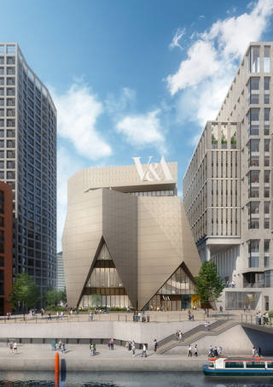
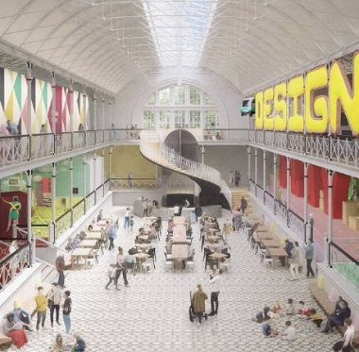
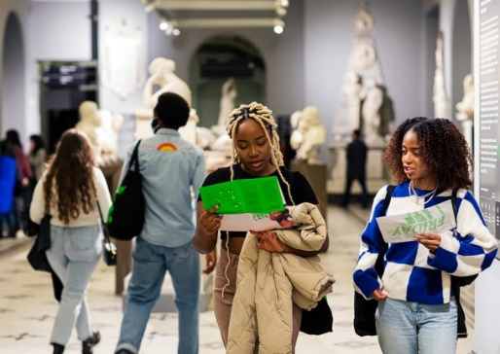
External render view of the new V&A East Museum at Stratford Waterfront, designed by O'Donnell + Tuomey. © O'Donnell + Tuomey / Ninety90, 2018
Internal render view across the Town Square space at Young V&A © Picture Plane / Courtesy of Victoria and Albert Museum, London
Friday Lates at V&A South Kensington © Victoria and Albert Museum, London
Equity, Diversity & Inclusion
We strive to integrate equality, diversity, and inclusion consistently and naturally into all our activities. We want to be proactive in recognising and removing the barriers that people from all backgrounds may face in accessing our collection, services, and employment. We recognise the value of difference, and we celebrate the creativity and productivity that diversity can bring to everything we do.

We are proud to be an open, tolerant, and diverse organisation. We want to do more to welcome a broader audience and develop a more diverse workforce. At the V&A we are committed to a strict zero tolerance policy on any discrimination, harassment or bullying regarding sexual conduct, race, sex, disability, gender, age, sexual orientation, beliefs, and socio-economic background.
We welcome and encourage job applications from people of all backgrounds and would particularly welcome applicants from those of a South Asian heritage or those who have lived within the South Asian community to act as an advocate and stakeholder for the project.
Learning at the V&A
Learning at the V&A ​builds creative confidence in all our audiences, and champions the skills needed to drive the future of the creative economy​. Through a responsive and relevant portfolio of activity, we strive to inspire current and future generations of artists, creatives, designers, and innovators.

The National Lottery Heritage Fund South Asia Gallery Interpretation Intern:
Main Purpose
Museum interpretation is the way in which we communicate the stories of our objects to audiences in our galleries and exhibitions. It ranges from text and films to audio guides and games to bring these stories to life. Successful interpretation considers what audiences’ interests and needs are, and ensures we tell stories in meaningful, relevant and engaging ways.
The Intern will support the work of the V&A Interpretation team in the development of interpretation for the transformation of the South Asia Gallery. You will primarily support the Head of Interpretation, Projects Interpretation Producer and Activity Plan Manager in creating the interpretation plan for the Stage 2 Heritage Fund Activity Plan and application. This will be an evolving process of researching, testing, experimenting, piloting and evaluating to develop and produce innovative gallery interpretation which is informed, and in part produced, by our audiences.
The role will offer varied experience across the range of tasks required in creating an interpretation scheme, from research and workshopping content, to helping with audience co-working groups and liaising with curators to ensure project documentation is kept up to date to reflect current thinking. Working with colleagues across the museum, you will learn how major FuturePlan projects are run and how the V&A collaborates with audiences to achieve its mission to champion design and creativity in all its forms, for everyone.
We are looking for an organised individual with good attention to detail and an interest in museums and/or working with audiences. You do not need to have previous experience, but you do need to have a passion for storytelling and engaging with others through stories. Additional training relevant to the role can be provided by the V&A.
Working to the ethos of putting audiences at the heart of the stories we tell, we are looking for an intern of South Asian heritage or who has lived within the South Asian community. This person will bring a fresh perspective to our work, while gaining valuable experience that will help them pursue a career in museums and develop key transferable skills such as research, project coordination and administration.

Key Responsibilities:
- To support the Interpretation and Curatorial teams in the development of the interpretation for the South Asia Gallery.
- Basic research: Carry out research into areas including South Asian topics, images and/or media resources.
- Perspective: Contribute own thoughts and knowledge to the gallery re-development project, and provide feedback on the outcomes of the internship to the V&A for inclusion in the Heritage Fund evaluation.
- Team support: Work with the Curatorial and Interpretation teams to gather materials and content for co-working sessions.
- Administration: Carry out basic administrative tasks as required, for example booking rooms, taking notes etc.
- Development: Learn the process of and contribute to the creation of the interpretation plan.
- Experience: Work with South Asia Gallery project team members and wider V&A staff departments to carry out ad hoc project duties and creative tasks as requested.
- Be committed to health and safety and ensure familiarity with the museum's health and safety policies and procedures.
- Be security conscious, ensure familiarity and co-operation with all museum security procedures and ensure you wear a security pass at all times when on museum premises.
- Promote equality and diversity in all aspects of your work by developing and maintaining positive working relationships, ensuring that colleagues are treated fairly and with respect/dignity and actively contributing to developments that support the museum’s strategy for widening access, inclusion and diversity.

The above job description is intended to be an outline of the duties and responsibilities for this role. This is not a full list, and it is likely to change over time. You may be expected to undertake other duties that are relevant for this role.

We are looking for someone who has:
- Job Specific:
  - An interest in museums, storytelling and communications.
  - Knowledge of the culture, place and people of South Asia.
  - An interest in working with audiences in the cultural and creative sector.
- Skills:
  - Good organisational skills, with experience of managing own time and workload to meet deadlines.
  - Good standard of written English (GCSE Grade C equivalent) and numerical ability to perform a range of calculations.
  - Experience of communicating clearly, with the ability to adapt your communication style for different groups.
  - The ability to use MS Office and other relevant IT systems as appropriate for the role.
  - Demonstrates flexibility and the ability to manage multiple tasks.
- Behaviours:
  - Respects others’ expertise, time, perspectives and contribution.
  - Takes responsibility for delivering on actions, achieving high-standards and learning from mistakes.
  - Open to change, new ideas and suggestions; looks for opportunities for improvement and self-development.
  - Works with others outside their own department in a collaborative, understanding, and engaging way.
- Desirable:
  - An understanding of museum interpretation.
  - Experience of working with or advocating for audiences and their needs.
What we can offer you:
- Generous pension scheme: post-probation 5.5% employee contribution, 10% employer
- Generous holiday: 29 days (pro-rata) plus bank holidays
- Flexible working options
- Tickets to V&A exhibitions for you, your friends or family
- 25% discount on V&A shops
- Give as you earn scheme (tax free charity donation scheme)
- An interest free season ticket or bicycle loan
- An interest free rental deposit loan
- Free safety check and small repairs to your bike with Dr Bike
- A wide range of training and professional development opportunities (apprenticeships, online training hub, regular training courses)
- Several staff diversity networks which bring together everyone at the with a shared interest in an equality issue to exchange information, support and influence positive change throughout the organisation. Members of staff diversity networks play an important role in promoting dignity and respect and understanding of diversity and inclusion at the V&A. Current staff diversity networks include: Disability Action Group, Anti-Racism Taskforce, Decolonisation Reading Group.
- An Employee Assistance Programme which provides information and support on a range of topics, from health and fitness to finance, childcare and counselling. This free, confidential service is available to all our employees online and on the phone 24/7 and includes a bullying and harassment helpline.

Hours:

This post is part-time, 3 days a week. Net working hours (i.e., excluding meal breaks) are 21.75 per week.

Normal working hours are 9am–5.15pm Monday to Thursday and 9am–5pm Fridays. Exact days and working hours for this role will be agreed with the Line Manager after appointment.

Key Dates:

Closing date: Midday, Wednesday 11 December 2024

Interviews: Thursday 9 and Friday 10 January 2025
How to Apply:

Please include your written responses to the following questions in the ‘supporting statement’ section of the online form, (300 words max per answer). You can use your previous work, school or volunteering experience to illustrate your answers.

- What interests you about this internship and what do you hope to get from it?
- Describe a time when you had to think creatively to communicate an idea and/or complete a task.
- Describe an occasion when you had to use your organisational skills to manage different demands on your time. Please tell us what you did and how, and what was the result.
Position in the team:

Head of Interpretation

Senior Interpretation Editor

Interpretation Intern


